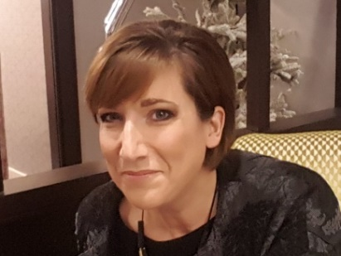
A message from the
Director of Fundraising,
Ovarian Cancer Action

Did you know that 7,495 new cases of ovarian cancer are diagnosed on average in the UK every year and that for 70-90% of women diagnosed, their disease will come back? The reality is shocking, survival rates for women with ovarian cancer are 50 years behind those of breast cancer, leading to a woman dying in the UK from ovarian cancer every two hours. Ovarian cancer is an overlooked cancer that has sat in the shadows for too long, but we are here to change all that and to fight for the thousands of women with ovarian cancer and ensure they are ignored no longer. We are doing that in two ways; awareness raising and scientific research.

Since we were founded in 2006, together with our supporters we have invested almost £13m in ground-breaking scientific and clinical research, with outstanding results. Our researchers continue to make great progress, contributing 11 new ovarian cancer discoveries in the last year alone and we also recently launched our ground-breaking ‘Improve UK’ project in partnership with the British Gynaecological Cancer Society, funded by the UK Government, where we are supporting six projects across the UK to drive clinical improvements and ensure all patients have access to the best standard of care.

The importance of supporting women with ovarian cancer has never been greater and with our new organisational strategy, growing brand awareness and talented team, this is an exciting time to join Ovarian Cancer Action and become a part of a growing and ambitious organisation.

The fundraising team currently brings in over 2m and despite Covid’s impact, the team has seen some good growth and success particularly in trusts, individual giving, and statutory income. Our priority moving forward will be to strengthen and grow these areas further but also to invest and focus on other key areas of income generation such as individual giving & community fundraising, to diversify our income base and strengthen our sustainable income levels.

Our approach as a fundraising team as we move forward will be one of passion and determination. We are open to new approaches and opportunities, and we will be driven by data and learnings to inform our choices and priorities and most importantly, we are and will be supporter led at all times.

The trustees and leadership team are all extremely committed to supporting and enabling income growth. They are very much behind the plans and required early investment in the fundraising team and so as part of moving forward with our fundraising plans, I am looking for some exceptional candidates to fill two permanent and new roles in the team: Trust Officer, and Community & Events Manager.

So, if you are looking to become a part of a dynamic, ambitious, and passionate team, then I very much look forward to receiving your application and potentially working with you to improve the future for the thousands of women with ovarian cancer across the UK. I look forward to hearing from you soon.
Vicki Bednall, Director of Fundraisng

Role and Organisational Profile

Position: Senior Trust Officer
Salary: £28-£32k (depending on experience)
Reports to: Trusts Manager
Start date: ASAP
Contract type: Permanent/full time/part time considered (4 days)
Place of work: There will be a hybrid of remote/home and office-based working from a central London workspace of 1-2 days per week, subject to Covid regulations. There may be occasional work outside regular office hours at charity events (with time off in return).

About Ovarian Cancer Action

Ovarian Cancer Action’s vision is to make ovarian cancer a survivable cancer for all women. Today, sadly only 3 in 10 women diagnosed with ovarian cancer live beyond ten years. It is the UK’s most deadly gynaecological disease, killing over 4,100 women every year.

At OCA, we are on a determined mission to transform survival rates so by 2032 at least half of women with ovarian cancer live for 10 years. To achieve real change for women with ovarian cancer, we undertake crucial work across key priority areas:

- Accelerating research will have the biggest impact on survival rates. Since our inception in 2006 we have invested almost £13 million in ground-breaking scientific and clinical research across three areas: prevention, earlier diagnosis, and more effective treatments – more than any other ovarian cancer charity. Last year alone our researchers contributed 11 new ovarian cancer discoveries.
- Raising awareness is vital to ensure women are diagnosed early, as 5-year survival is 93%, compared to 13% at late stage, but nine in ten women are unaware of all the symptoms of ovarian cancer. Our life-saving national awareness campaigns targeting women, health professionals and higher risk communities aim to promote earlier diagnosis and increase hereditary cancer prevention.
- Leading change: we amplify the patient’s voice and collaborate to drive improvements in early diagnosis and care. In 2020 we secured £1.2m from the UK Government’s Tampon Tax Fund for a ground-breaking ‘Improve UK’ project in partnership with the British Gynaecological Cancer Society to tackle severe regional and systemic inequalities in outcomes experienced by patients. We envisage this will benefit patients over the next 2-5 years.

Over the last fifteen years, our efforts to fund and facilitate the very best ovarian cancer research have achieved dramatic results. But we know there is a long way to go. Treatments and survival for ovarian cancer sadly lag far behind other cancers that have been the target of greater investment, and we are determined and resolute that ovarian cancer is not overlooked any longer. 2022 is an exciting time to be joining the organisation as we launch our new research strategy and ambitious plans to drive forward progress at a faster pace.

Watch this video to learn more about what we do and the impact we have.
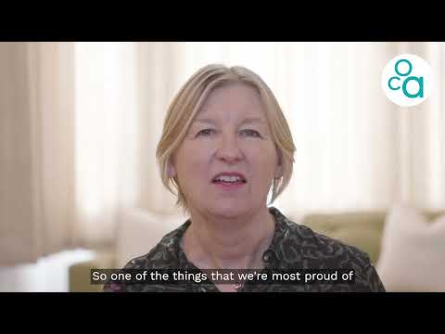
About the Role

Main purpose of the role
The Senior Trust Officer will lead on securing funding from small- to mid-level charitable trusts and other grant-giving organisations. The post-holder will account manage a portfolio of funders and grow their support, preparing and submitting compelling proposals and ensuring excellent stewardship of our supporters. The post holder will also work with the Trusts Manager to support some of the larger applications and funders, as well as work across teams to ensure effective delivery and stewardship of any relevant funding commitments.

OCA has an ambitious new organisational strategy, but we know we cannot deliver that ambition and the change that is needed for women with ovarian cancer, without an ambitious fundraising strategy and team. Therefore, the fundraising team are at a very exciting phase of our growth and development, looking to expand from our current pool of incredibly loyal supporters to new activities and ways of working, ensuring our supporters at the heart of all we do. The Senior Trusts Officer is one of three new, permanent roles within the growing fundraising team.

Please see below for a full job description and person specification.

Benefits
- 25 days annual holiday leave
- Pension
- Flexible mix of office and remote working
- Eye test and financial support with glasses if required
- Training and development opportunities
- 24 hour confidential and free Employee Assistance Programme to support you with both personal and work-related issues and, if required, confidential counselling sessions
- Social events for the team

Recruitment process
Thank you for your interest in this role. We would like to invite you to apply to work with us by sending a cover letter (no more than one side) of why you are interested in working with OCA, specifically highlighting your relevant experience and personal attributes as detailed in the person specification, together with a copy of your latest CV. All applications to be submitted to: jobs@ovarian,org.uk
Please note that we will be interviewing as applications are received so please submit promptly.

Please do also look at our website www.ovarian.org.uk for more details about who we are and what we do.

