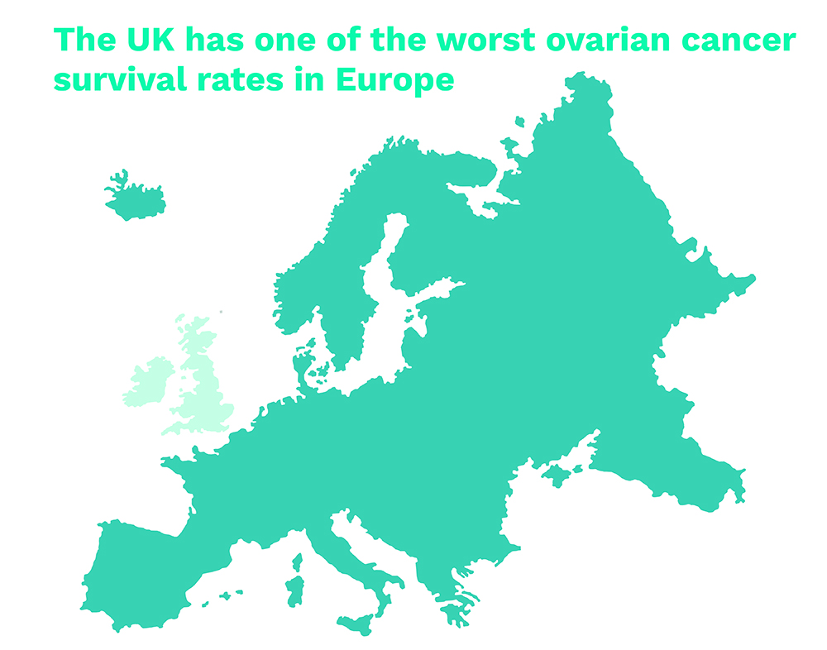
Ovarian cancer survival rates in the UK are among the worst in Europe.

Dear [insert your MPs name here],
When a woman is diagnosed with ovarian cancer in the UK, the odds are stacked against her. We have one of the worst survival rates in Europe - only 36% of women will survive five years beyond their diagnosis.
March is ovarian cancer awareness month and the charity Ovarian Cancer Action is calling on MPs to pledge their support and take action to transform survival rates for women with ovarian cancer in their constituencies.
By pledging your support you could help in a number of easy ways:
- Organising a coffee morning in your constituency to raise awareness
- Writing to your Clinical Commissioning Group about their plans to improve survival rates
- Supporting Ovarian Cancer Action’s campaigns in Parliament
I would be grateful if you could support this campaign.
Yours sincerely,

[Insert your name here]
[Insert your full address and postcode here]

